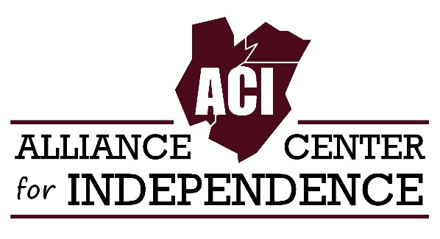
COVID-19 VACCINE SURVEY FOR PEOPLE WITH DISABILITIES
The Alliance Center for Independence is planning a panel discussion on COVID-19 vaccines that is open to the disability community. The purpose of the event is to provide the disability community with information so that individuals can make an informed choice about getting or not getting a vaccine.

To help in the planning process, ACI is asking our consumers to fill out the following survey.

Please send completed survey to Luke Koppisch at lkoppisch@adacil.org or mail to 629 Amboy Ave, Edison, NJ 08837. Thank you!
Full Name

Email
- Sign Up for ACI Newsletter
Phone

Disability or health condition
Have you received a vaccine for COVID-19? *
- Yes
- No

If so, which one?
- Pfizer
- Moderna
- Johnson & Johnson
If not, please check the reason(s) (please check all that apply)
- I worry the vaccine is not safe.
- I worry about the side effects of the vaccine.
- I worry that the vaccine is not effective.
- I worry about having a bad reaction to it on account of my disability/pre-existing condition.
- I don’t have transportation to get a vaccination site or pharmacy.
- I am housebound and have trouble arranging for the vaccine at my home.
- I don’t have time to get the vaccine.
- I don’t desire to get a vaccine at this time (please explain in the box below).
Do you have enough information on the vaccines? *
- Yes
- No
- Other
Do you know where to go to receive resources on the vaccines? *
- Yes
- No

* = required
629 Amboy Ave, Edison, NJ 08837 ● adacil.org ● adacil@adacil.org
732-738-4388 ● Fax: 732-738-4416 ● TTY: 732-735-9644 ● VRS: 732-709-1023

