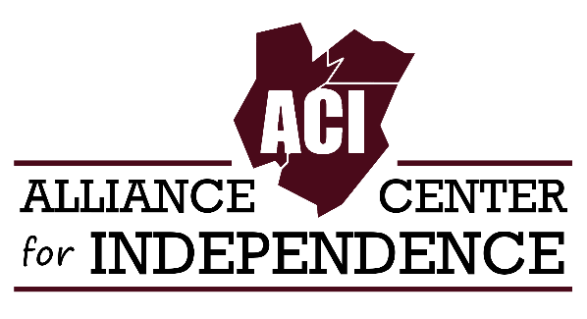
For Immediate Release
Carole Tonks
Executive Director
732-738-4388
ctonks@adacil.org

ACI CommUnity Market Grand Opening
EDISON, NEW JERSEY - The Alliance Center for Independence (ACI) is happy to announce the grand opening of its reimagined food pantry, the ACI CommUnity Market!
Join Edison Mayor, Sam Joshi, members of the Edison Township Council, and other supporters on Thursday, April 7th for the ribbon cutting ceremony! This in-person event will take place at 629 Amboy Ave (S & P Building) Suite 110, Edison, NJ 08837 from 1:00 to 3:00 PM.
Since 2016, ACI’s food pantry has assisted hundreds of low-income individuals with disabilities and their families. Demand for our food pantry increased tremendously throughout the COVID-19 crisis. “During the pandemic, we shut down the office and staff worked at home, but we kept our food pantry doors open,” said Carole Tonks, Executive Director of ACI. “There was a need in the community and it was important for us to meet that need.”
The CommUnity Market concept will feature consumer choice and customer service while expanding our assistance to disabled individuals and their families facing food insecurity. Staff will also help individuals apply for SNAP and make referrals to social service organizations and other food pantries in the area. The CommUnity Market will also offer training to individuals with disabilities interested in working in the retail business.
The ACI CommUnity Market is 501(c)(3) not-for-profit serving Middlesex, Somerset, and Union counties and is supported by PSE&G, Unity Bank, REPLENISH of Middlesex County, Guarantee Rate, and individual donors.

